**MIMIC to Emory**

1. **BED LOCATION**

1. **ENCOUNTER**

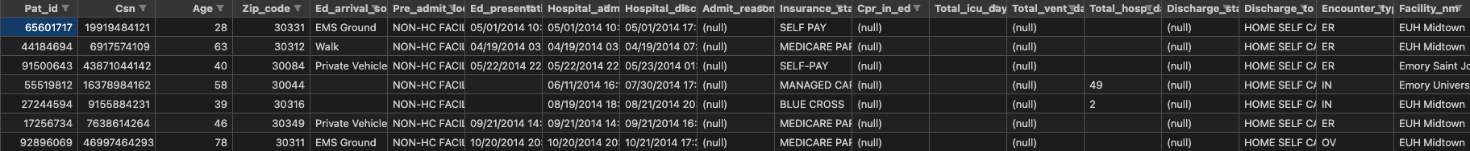

1. **NON_INFUSED MEDS**
2. **VITALSCalendar

   Description automatically generated**
3. **LABS**
4. **SENSITIVITIES**

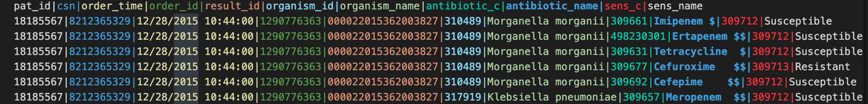

1. **DIAGNOSISTable

   Description automatically generated with medium confidence**
2. **DEMOGRAPHICS**

1. **ICDPROCEDURES**
2. **VENT**
3. **GCS**

1. **CPT**
2. **CULTURES**
3. **INFUSEDMEDS**
4. **ORPROCEDURES**